Kaggle Image Matching Challenge 2025 – Group 44

Luchiean Tudor - Baumeler Luc - Rostovs Samsons - Jervis Tham Kai Kit - Chou Yu-Fan
N2601726K - N2601722L - N2601725B - JERV0007 - CHOU0019

Introduction to the Challenge
The Image Matching Challenge 2025, from here on out referred to as the IMC2025, is a 3D reconstruction challenge. Given a set of pictures, a group must first identify which pictures depict the same scene and then reconstruct the camera position and angle for each picture. One additional difficulty is the outlier pictures added to the dataset that do not belong to any of the scenes and exist with the sole purpose of increasing the matching and reconstructing difficulty.
Just like the challenge consists of two parts, so does the scoring. The first component of one’s score is the clustering score C. This represents the proportion of how many images in any of the predicted clusters belong to the corresponding ground-truth scene. The second component is the mean average accuracy mAA, which describes the accuracy of one’s reconstruction, considering the number of correctly reconstructed images and their camera center accuracy at different distance thresholds. Next, for every dataset the harmonic mean of C and mAA is computed using the formula 2*C*mAA/(C+mAA). The idea behind this formula is to combine both clustering and reconstruction accuracy in a way where a good final score requires both values to be high. A poor performance in one category cannot effectively be balanced with a good performance in the other category. The final score is the average over all the evaluated datasets.
Our approach
Considering that we are five people working on this project, we based our idea on a modular approach, so that everyone can experiment with their own features, benchmark them and see how well they perform, and then share their learnings with the others. Thus, our project had three phases. First, we implement a basic pipeline that generates a starting score and divide it into modules that can later be swapped out for different ideas. Then, we all get a copy of this basic pipeline and start swapping out different modules, playing around with hyperparameters and trying to somehow optimize as much as possible. Finally, we all came back together and combined our findings into one pipeline to try and get as good of a score as possible.
Report structure
The report will start with an explanation of our basic pipeline, going into a bit more depth on the different steps that it is made up of and why every step is necessary. Then we will go through the different modules that we tried swapping out, which ones worked out well and which ones we were not able to see a direct improvement from. In the end, we will summarize our final solution, explaining how we got there and why we decided to opt for that design.
Along the way we will share relevant insights, benchmarks and tests what we ran to compare performances and problems and difficulties we came across along the way.

// maybe something to fill the first page and have the explanations start on the second one

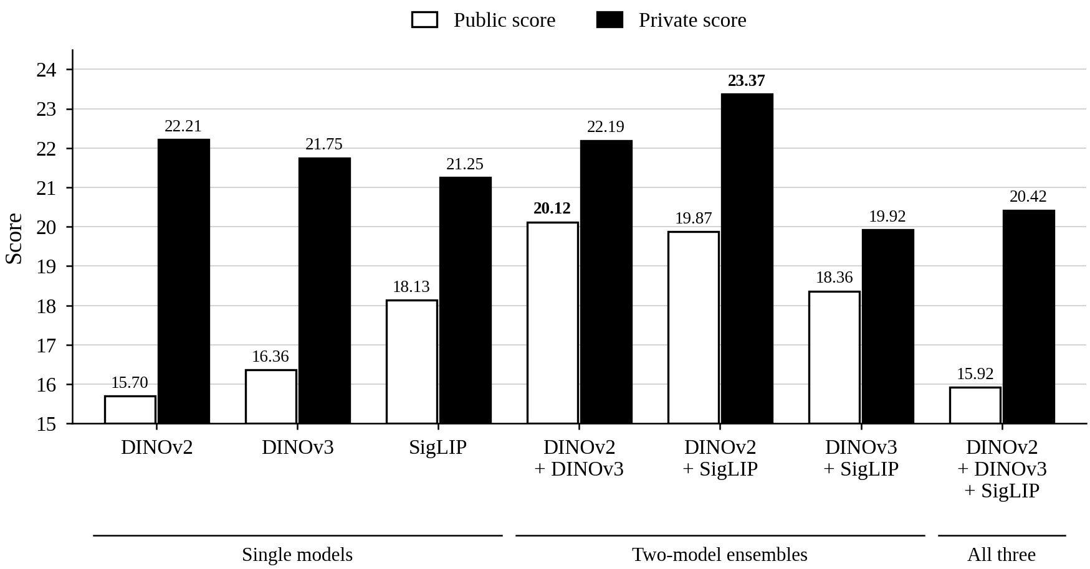
The Basic Pipeline
The basic pipeline design we decided on after reading through common approaches online and analyzing past contenders was a three-step setup.
In the first step, we embed the pictures using DINOv2 into vectors, extracting the content from the pictures. We then use these vectors with cosine-similarity and k-nearest-neighbors search to obtain promising image pairs.
The second step is all about matching the pairs and verifying the matchings. We first used SuperPoint to extract each picture’s keypoints and descriptors. Then, taking the image pairs we obtained in the first step, we run LightGlue on them and try to match as many keypoints between each pair of pictures. As LightGlue can find keypoint matches that look correct but are geometrically impossible or inconsistent, we verify geometric consistency by implementing RANSAC with OpenCV. Finally, using NetworkX, every verified image match is gathered and combined into one graph, where each connected component represents a reconstructed scene.
The final step builds on the image graph and reconstructs the camera positions and angles. This is achieved by converting our graph into a COLMAP database that contains the information required for the Structure-from-Motion process, for which we used the PyCOLMAP library. The pipeline ends with the extraction of the camera position and angle, which are then put into the right submission.csv output format.
Embeddings
Starting from the DINOv2 base pipeline, the first thing we did was try out different embedding models. The three that we tried out were DINOv2, that most contenders also used, Meta’s new DINOv3 and SigLIP, which is a model that should perform better on images where the semantic context matters more than the fine visual details. To determine which model is the best, we ran the default pipeline but swapped out the embedding with seven different versions, one for each possible combination of embedding models. The results of that first testing can be seen in image XXX. We can see that the two combinations of DINOv2 with DINOv3 and with SigLIP seemed to perform the best. While multiple models show promising embeddings in the private evaluation score, only the two previously mentioned combined embeddings had convincing public scores. Thus, those two models were the ones we continued with and ran different optimization tests on.
The first logical next step is to try to vary the weightings between the two embeddings in both models. As we can see from the figure, this shows to barely make a difference. The only pattern one can see is that the difference between public and private scores are large when we start moving too far away from DINOv2.
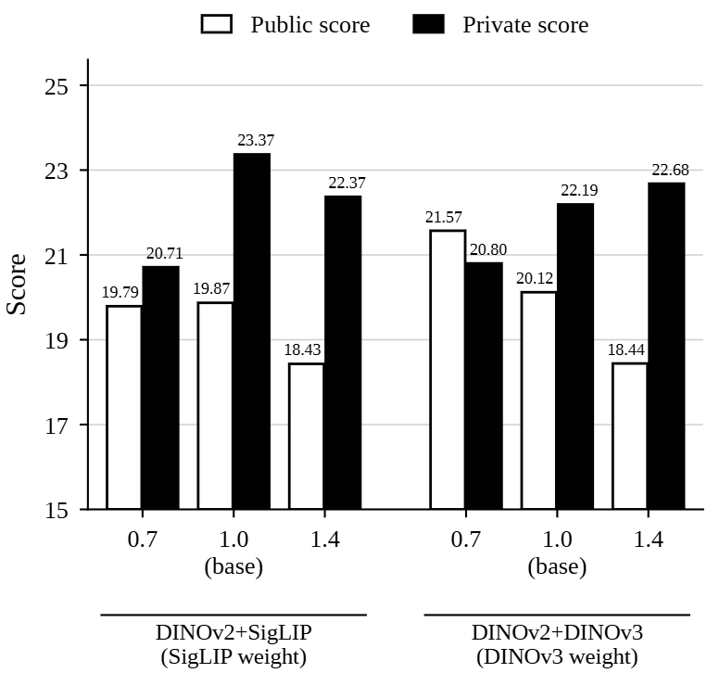
Next, we tried increasing the resolution that the models are working with. The expectation would be that a higher resolution would also result in a higher embedding quality, but the experiments do not fully support that idea.
We also tried our different pooling methods for the two DINO models, but that also did not seem to have a significant impact on the scores.
Our final idea was to implement Flip Test-Time-Augmentation, FlipTTA. The basic idea is to take a picture and its corresponding vertical mirror and to combine the embedding of both pictures into one. Technically, this should improve the embedding when the input data is sensitive to orientation of objects. The results suggest that accounting for the orientation does, however, not make much of a difference. On the contrary, for the SigLIP combination the public dataset seemed to heavily decrease in performance. It is interesting to notice how it did not affect the private part of the dataset by the same amount.
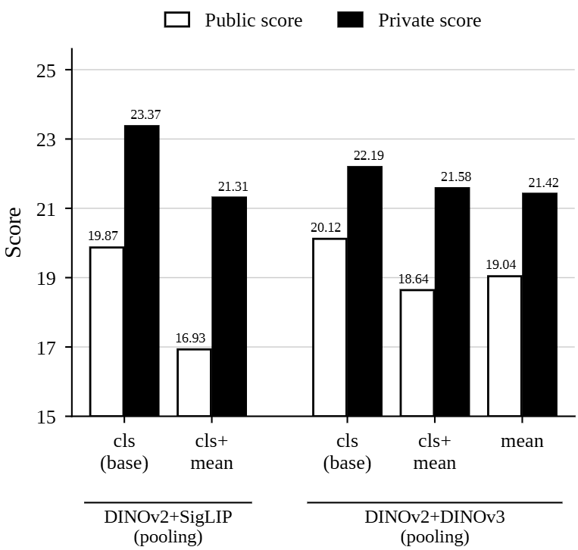
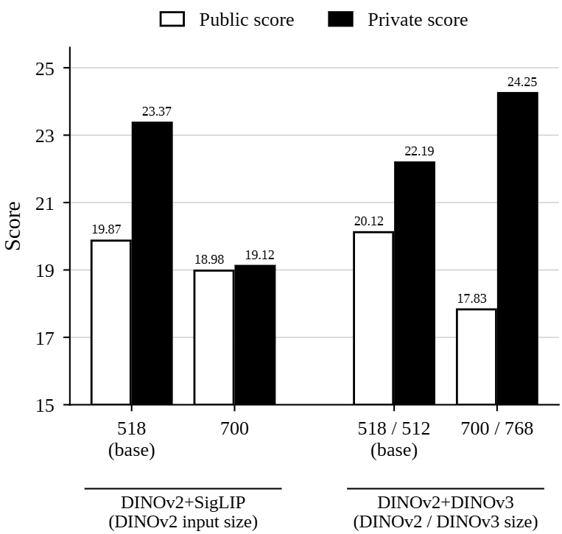
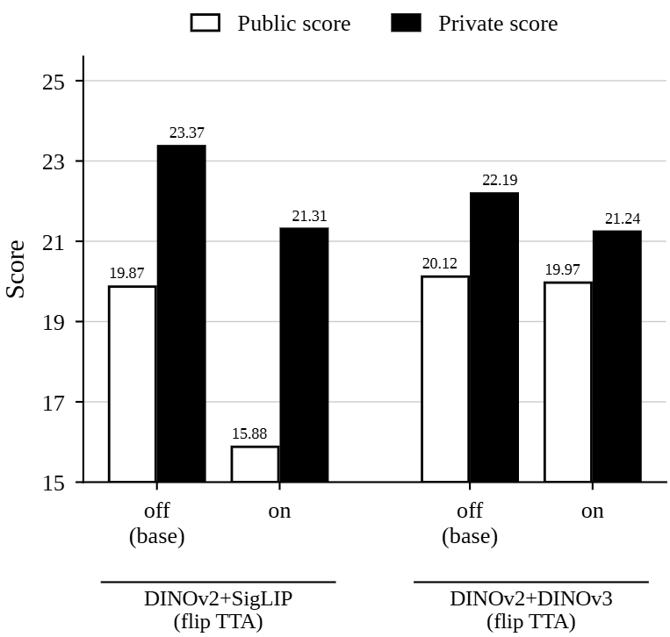
Most of the results we found point to a similar direction. First, the randomness of our pipeline and the way the final output is generated seems to influence the scores. That means that for every score that is within a margin of about 2 score points, it is difficult to determine whether our tests changed the performance, or it was just a lucky/unlucky run. The data we gathered should therefore be taken with a grain of salt.
Second, seeing that most of our tests only had a very small influence on the score suggests that the bottleneck of the default pipeline is likely somewhere else.
With these results in mind, we move on with these two embedding models to the next stage, the pair shortlisting.
Pair Shortlisting
The first thing we tried was to increase the k of the knn search algorithm. Instead of outputting the 40 most similar we output the 60 most similar. The negative change in scores can be explained by this first initial sieve being too coarse. Increasing the k only adds more image pairs that are abstractly speaking further apart, which likely adds more potential pairs that are not from the same scene. While this does not decrease the chances of finding good image matches, it does increase the likelihood of adding wrong matches, which worsens the score. Furthermore, adding 60 images as potential matches increases computing time, which is another reason to keep k at 40, or potentially try to further decrease it.
The next test was to first separately compute the top 30 nearest image matches with each contributing model and to then combine the two lists into one set. For the DINOv2/SigLIP combination this only significantly decreased private performance. The DINOv2/DINOv3 combination shows barely any changes, likely due to the two model’s embeddings already having similar embeddings and thus considering similar images as close.
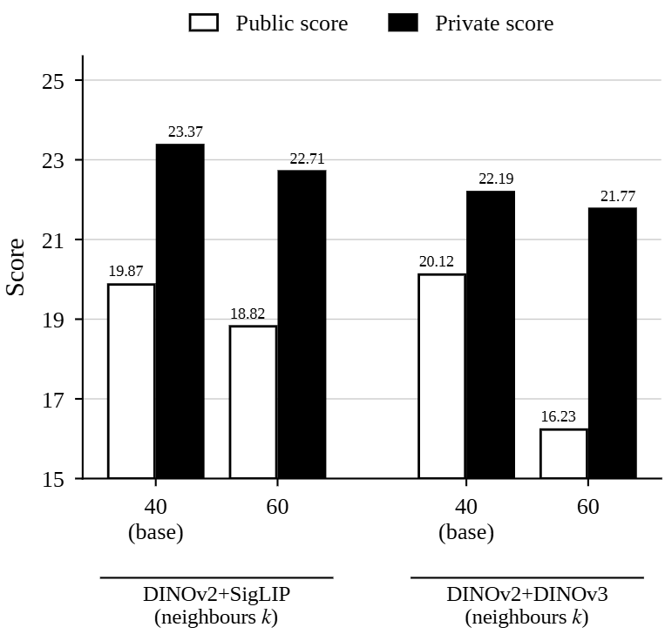

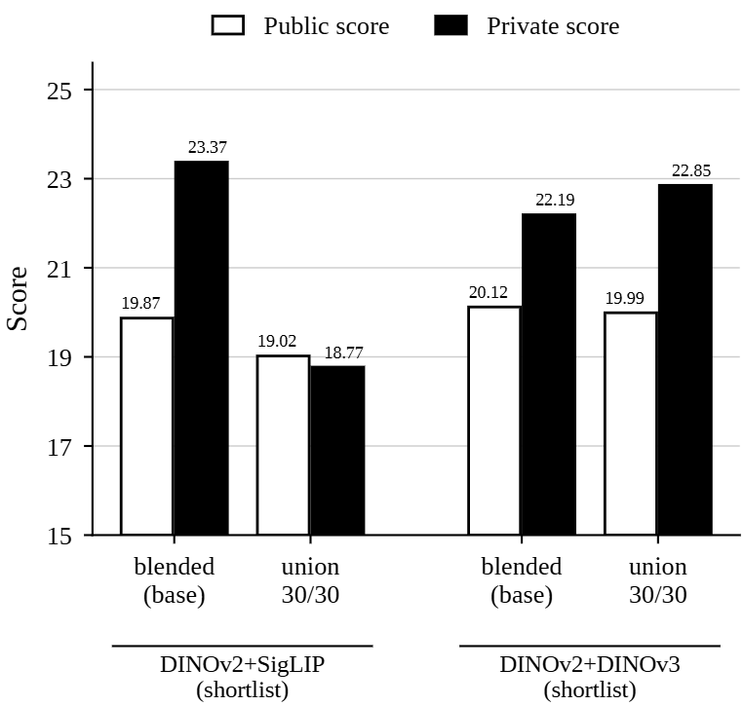
Another idea we tried was to have two shortlisting runs, the first one finding the closest matches. After that, for each image we take some of the closest image matches and merge them into the originals picture embedding. Having done all of that for all pictures we rerun the knn search and find the k closest images. This procedure is known as query expansion, but it did not show any promising results. On the contrary it worsened the original score, which is likely due to it possibly combining image embeddings that do not come from the same underlying scene.
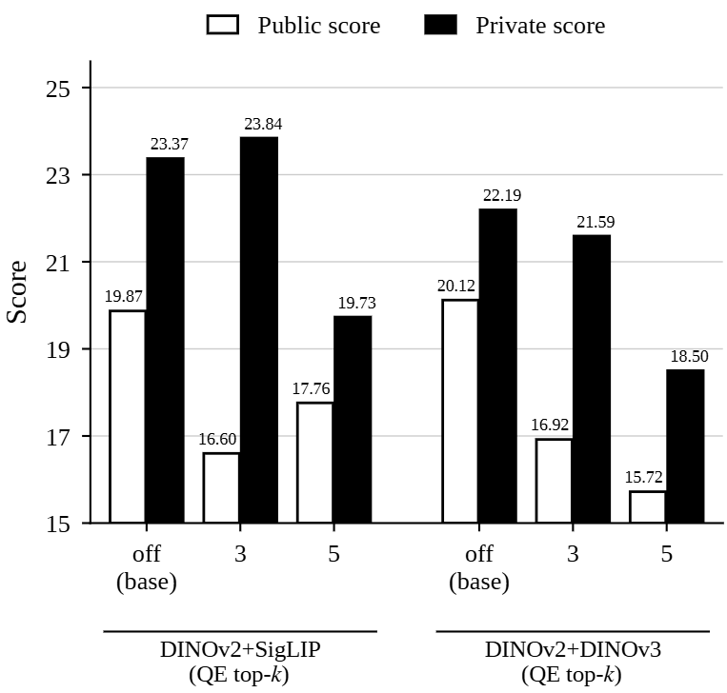
Finally, we tried four different distance measurements for the knn search, being the regular cosine similarity, non-normalized Euclidean distance, Manhattan distance and mahalanobis distance. From the results we can extract that the basic cosine similarity we used before might not be the optimal approach. The difference between normalized and non-normalized Euclidean seems to not be that relevant, whereas Manhattan distance performs better on the DINOv2/SigLIP combination, showing barely any improvement in the DINOv2/DINOv3 combination. What can be said for sure however is that the mahalanobis distance, relying on standard distributions as distance metric, performs the worst and will thus not be considered.
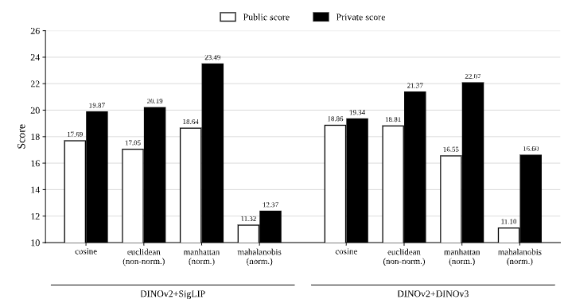
Keypoint Extraction
Luc
Keypoint Matching
Luc
Geometric Verification
This steps goal is to perform geometric verification of the keypoint correspondence we found in the last step. Given the keypoints we estimate a geometric model that describes the relation of the two pictures. We then check which keypoint matches are consistent with this estimation and which ones are not, putting them into two categories of inliers and outliers. Our basic pipeline used the standard RANSAC algorithm to estimate the fundamental matrix, but in this section we will show our findings in trying out multiple robust estimation algorithms and geometric model combinations. The algorithms we compared include RANSAC, Locally optimized RANSAC, MAGSAC++, PROSAC and USAC while considering three different geometric models in the fundamental matrix, the essential matrix and the homography matrix.
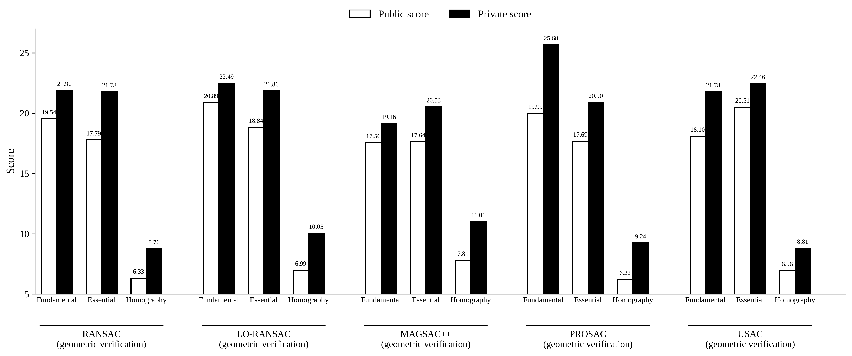
The results paint a pretty clear picture regarding the homography matrix. Both public and private values are considerably worse than the fundamental and essential matrix and the fundamental and essential matrix seem to have almost the same values throughout all the tests. Intuitively, this makes sense as they use the same underlying epipolar geometry but just have different coordinate systems. The essential matrix has a stronger tie to the physical camera motion but therefore also needs more parameter finetuning, while the fundamental matrix is more flexible without calibration.
There is one interesting outlier that scored much better than any other combination, being the fundamental matrix with PROSAC. This margin of more than 3 points over the next private score is difficult to assign to randomness, so it might be worth implementing it in the final pipeline.
Finally, we wanted to see if playing around with the focal length of the essential matrix would be able to match the fundamental matrix with PROSAC. Our test suggests that

Graph/Reconstruction
Samson

Final Pipeline Setup
Final Discussion

Copyright (This Is a Section Heading)
All papers submitted for publication by AAAI Press must be accompanied by a valid signed copyright form or, in the case of technical reports, by a valid signed permission to distribute form. There are no exceptions to this requirement. You must send us the original version of this form. If you fail to send in a signed copyright or permission form, your paper cannot be published. You will find PDF versions of the AAAI copyright and permission to distribute forms in the author kit. (This is an example of the Text style. Note that it is justified, and that hyphenation is turned on.)
(This is an example of the Text-Indent style. It is identical to the Text style, except that each paragraph is automatically indented.)

Formatting Requirements in Brief
We need source and PDF files that can be used in a variety of ways and can be output on a variety of devices. AAAI imposes some requirements on your source and PDF files that must be followed. Most of these requirements are based on our efforts to standardize conference manuscript properties and layout. These requirements are as follows, and all papers submitted to AAAI for publication must comply:
• ALL FONTS MUST be embedded in the PDF file. (Your paper cannot be corrected or published if the fonts are missing.)
• No type 3 fonts may be used (even in illustrations).
• All text in your paper must be black. Use of any colored type must be restricted to figures.
• Your title must follow the Chicago Manual of Style (CMOS) title-case capitalization rules. That means all verbs (including short verbs like be, is, using, and go) nouns, adverbs, adjectives should be capitalized, including both words in hyphenated terms, while articles, conjunctions, and prepositions are lower case unless they directly follow a colon or long dash.
• Word documents must use the Times, Time Roman, Times New Roman, URW Nimbus Roman or TeX Gyre Termes fonts. Use of any other fonts in the text, title, heading, or references is not permitted.
• Fonts that require non-English language support (CID and Identity-H) must be converted to outlines or removed from the document (even if they are in a graphics file embedded in the document).
• Two-column format in AAAI style is required for all papers.
• The paper size for final submission must be US letter (8-1/2 x 11 inches). No exceptions.
• The source file must exactly match the PDF.
• The document margins must be as specified in the formatting instructions. Ensure that the specifications are for the whole document, not just the first section.
• The number of pages and the file size must be as specified for your event.
• No document may be password protected.
• Neither the PDFs nor the source may contain any embedded links or bookmarks. URLS in your document must be black, and may not be underlined.
• Your source and PDF must not have any page numbers, footers, or headers.
• Your PDF must be compatible with Acrobat 5.

If you do not follow the above requirements, it is likely that we will be unable to publish your paper.

What Files to Submit
You must submit the following items to ensure that your paper is published:
• A fully-compliant PDF file.
• Your Word “docx” source file (required).
Your Word source will be reviewed and your PDF may be recompiled on our system. Name your source file with your last (family) name.

Using Word to Format Your Paper
AAAI Press has provided a Word template that you can use to create your paper. You must be careful, however, not to change the page set-up of this document (print a PDF and use “shrink to fit” if you need to print it on A4 paper), and you will encounter problems if you use Identity-H or CID fonts. If your paper contains many in-line equations, and a significant amount of display mathematics, you may achieve better results using LaTeX, although the learning curve for this program is significantly higher. AAAI does not offer support in the use of Word or LaTeX.
You are required to use the above custom style sheets embedded in this document without alteration. Do not use the built-in Word styles such as Header, Normal, and Heading 1.
Style Sheets (This Is an Example of a Subsection Heading)
The Word template provided by AAAI Press supplies custom styles for the most common elements in conference papers. Use of the following style sheets is required:
• Abstract Head
• Abstract Text
• Affiliation and Address
• Author Name
• Bulleted List
• Extract
• Figure Caption (must also be used for Tables)
• Footnote Text
• Paper Title
• Paper External Links
• References
• Section Heading
• Subsection Heading
• Text
• Text-indent

Word Copyright Notice
The copyright notice has been added to the Word template using an invisible, unnumbered footnote, appended to the example of a first-level heading. Don’t delete it! Instead, carefully insert your own heading at the left of the existing type, then remove the old type, being careful not to remove the invisible footnote marker at the end of the line. Be sure the copyright date is correct. (If you disable this footnote and transfer of copyright is required, your paper will not be included in the proceedings or digital library.)

Size, Margins, and Column Width
Papers must be formatted to print in two-column format on 8.5 x 11 inch US letter-sized paper. The margins must be exactly as follows:
• Top margin: 1.25 inches (first page), .75 inches (others)
• Left margin: .75 inches
• Right margin: .75 inches
• Bottom margin: 1.25 inches
The Word template is automatically set with these margins. Be certain, however, that the document margins apply to the entire document, not just the first section.

Column Width and Margins (This Is a Subsubsection Heading Example)
To ensure maximum readability, your paper must include two columns. Each column should be 3.3 inches wide (slightly more than 3.25 inches), with a .375 inch (.952 cm) gutter of white space between the two columns. The Word template will automatically create these columns for you.
Nothing may intrude into the outside margins — including boxes around figures. Documents and tables may span two columns, but single-column figures, tables, and equations must remain completely within the column width.

Overlength Papers
If your paper is too long, turn on hyphenation, which will reduce the space used by many lines. Next, shrink the size of your graphics. No alterations to page layout are allowed. Do not use formatting tricks to make your paper a certain length. Cut text or remove figures instead. If your conference allows it, pay for an extra page.

Type Font and Size
Your paper must be formatted using the style sheets embedded in the Word Template. They will automatically format your paper in 10 point Times, Times Roman or Times New Roman. We will not accept papers formatted using other fonts (except that Cambria may be used for mathematics only.) This document is formatted in 10 point Times New Roman.
Line spacing for text must be exactly 12 point. The style file for “Text” sets the line spacing at 12 point. You may not alter line spacing or point size.
Do not use type 3 fonts for any portion of your paper, including graphics. AAAI will not accept electronic files containing obsolete type 3 fonts. Files containing such fonts (even in graphics) will be rejected.
If you are unsure if your paper contains type 3 fonts, view the PDF in Acrobat Reader. The Properties/Fonts window will display the font name, font type, and encoding properties of all the fonts in the document. If you are unsure if your graphics contain type 3 fonts (and they are PostScript or encapsulated PostScript documents), create PDF versions of them, and consult the properties window in Acrobat Reader.
Start all pages (except the first) directly under the top margin. (See the next section for instructions on formatting the title page.) The Text-Indent style will automatically insert the proper indent when beginning a new paragraph. It should be used unless the paragraph begins directly below a heading or subheading. Do not skip a line between paragraphs.

Title and Authors
The title must be written in Title Case according to the Chicago Manual of Style rules. The rules are a bit involved, but in general verbs (including short verbs like be, is, using, and go), nouns, adverbs, adjectives, and pronouns should be capitalized (including both words in hyphenated terms), while articles, conjunctions, and prepositions are lower case unless they directly follow a colon or long dash. You can use the online tool at titlecaseconverter.com to double-check the proper capitalization (select the “Chicago” style and mark the “Show explanations” checkbox. Your title must centered over both text columns in 14.5-point bold type. The Paper Title style will automatically apply the proper font size and leading to your title.
Author’s names should appear centered below the title of the paper in boldface. You must use the Author Name style, which will automatically apply the proper size, font, and spacing. If you have many authors simply separate the author names with commas. You may then use superscript numbers as a key to their affiliations, which should appear in the affiliation lines (one affiliation per line) below the author list.
Affiliations and contact information must appear centered below the author names block. The Affiliation and Address style will automatically apply the correct formatting.
Do not use a table to provide this information. Please also note that no part of the title, author, or affiliation block may intrude into the margin.
You should begin the two-column format when you come to the abstract.

Credits
Any credits to a sponsoring agency should appear in the acknowledgments section, unless the agency requires different placement. If it is necessary to include this information on the front page, use a separate footnote. The AAAI copyright notice (required) must appear first in any list of footnotes.

Abstract
All conference papers must include an abstract. The abstract must be placed at the beginning of the first column, indented ten points from the left and right margins. The title “Abstract” should appear in ten-point bold type, centered above the body of the abstract. The Abstract Head style will automatically format this heading properly.
The abstract should be set in nine-point type with ten-point leading. The Abstract Head style will automatically apply these settings. This concise summary should describe the general thesis and conclusion of your paper. A reader should be able to learn the purpose of the paper and the reason for its importance from the abstract. The abstract should be no more than two hundred words in length. (Authors who are submitting short one- or two-page extended extracts should provide a short abstract of only a sentence or so.) Do not include references in your abstract!

Page Numbers
Do not print any page numbers on your paper.
Text
The main body of the paper must be formatted in ten-point with twelve-point leading (line spacing). The Text style in this document is 10 point with 12-point line spacing. The first line of text after a heading should not be indented. Subsequent lines of text within the same section or subsection should be indented 10 points. The 10 point tab is automatically set in the Word template. The Text-indent style will automatically apply the indent without having to use a tab.
URLs and Word
Microsoft Word’s default setting is to underline URLs and display them in another color. This causes the URLS to turn light gray when printed, and often makes them undecipherable. This feature must be turned off. Please also turn off the automatic linking feature in Word. Failure to do so will result in a page reformatting fee.
Automatic Links
Do not use Microsoft Word’s automatic section and reference linking.

Citations
Citations within the text should include the author’s last name and year, for example (Newell 1980). Append lower-case letters to the year in cases of ambiguity. Multiple authors should be treated as follows: (Feigenbaum and Engelmore 1988) or (Ford, Hayes, and Glymour 1992). In the case of four or more authors, list only the first author, followed by et al. (Ford et al. 1997).

Extracts
Long quotations and extracts should be indented ten points from the left and right margins. The “Extract” style provides this type automatically:
This is an example of an extract or quotation. Note the indent on both sides. Quotation marks are not necessary if you offset the text in a block like this, and properly identify and cite the quotation in the text.

Footnotes
Avoid footnotes as much as possible; they interrupt the reading of the text. When essential, they should be consecutively numbered throughout with superscript Arabic numbers. Footnotes should appear at the bottom of the page, separated from the text by a blank line space and a thin, half-point rule.
Headings and Sections
When necessary, headings should be used to separate major sections of your paper. Remember, you are writing a short paper, not a lengthy book: an overabundance of headings will tend to make your paper look more like an outline than a paper.
Section headings should be twelve-point Times New Roman bold type, mixed case centered. The Section Heading style will automatically apply these settings (including the extra required spacing). Subsection headings should be eleven-point Times New Roman bold type. The Subsection Heading style will automatically apply the proper settings automatically. Do not skip a line between paragraphs. Subsubsection headings should be ten-point Times New Roman bold type, mixed case, with twelve-point leading, flush left, with three points of additional space preceding them and no additional points of leading following them. The Subsubsection heading style will apply the appropriate formatting automatically.
Section Numbers
The use of section numbers in AAAI Press papers is optional.
Section Headings
Sections should be arranged and titled as follows:
- Main Content Sections
- Appendices (optional)
- Ethical Statement (optional, unnumbered)
- Acknowledgements (optional, unnumbered)
- References (unnumbered)
Appendices
Any appendices follow the acknowledgments, if included, or after the main body of text if no acknowledgments appear.
Ethical Statement
You can write a statement about the potential ethical impact of your work, including its broad societal implications, both positive and negative. If included, such statement must be written in an unnumbered section title Ethical Statement.
Acknowledgments
The acknowledgments section, if included, appears after the main body of text and is headed “Acknowledgments.” This section includes acknowledgments of help from associates and colleagues, credits to sponsoring agencies, financial support, and permission to publish. Please acknowledge other contributors, grant support, and so forth, in this section. Do not put acknowledgments in a footnote on the first page. If your grant agency requires acknowledgment of the grant on page 1, limit the footnote to the required statement, and put the remaining acknowledgments at the back. Please try to limit acknowledgments to no more than three sentences.
References
The references section should be labeled “References” and should appear at the very end of the paper (don’t end the paper with references, and then put a figure by itself on the last page). A sample list of references is given later on in these instructions. AAAI style is required for references. Poorly prepared or sloppy references reflect badly on the quality of your paper and your research. Please prepare complete and accurate citations.
Illustrations and Figures
Figures, drawings, tables, and photographs should be placed throughout the paper near the place where they are first discussed. Do not group them together at the end of the paper. If placed at the top or bottom of the paper, illustrations may run across both columns. Figures (including boxes and rules) must not intrude into the top, bottom, or side margin areas. Figures must be inserted using your page-formatting software. Number figures sequentially, for example, figure 1, and so on. There must be a minimum of 9 points between the figure and the figure caption, and an additional 12 points beneath the caption. There must also be 12 points additional space before a figure or table that does not begin at the top of a page.
The illustration number and caption should appear under the illustration. Leave some space between the figure and the caption and surrounding type; .25 inches should suffice. Captions should be presented in 10-point Times New Roman. Labels, and other text in illustrations must be at least nine-point type. The Figure Caption style will apply the appropriate formatting automatically.
Low-Resolution Bitmaps
You may not use low-resolution (such as 72 dpi) screen dumps and GIF files—these files contain so few pixels that they are always blurry, and illegible when printed. If they are color, they will become an indecipherable mess when converted to black and white. Gif files and low-resolution jpg or png files should never be used. The resolution of screen dumps can be increased by reducing the print size of the original file while retaining the same number of pixels. You can also enlarge files by manipulating them in software such as PhotoShop.
Using Color
The archival version of your paper will be printed in black and white and grayscale. Consequently, because conversion to grayscale can cause undesirable effects (red changes to black, yellow can disappear, and so forth), we strongly suggest you avoid placing color figures in your document. If you do include color figures, you must be mindful of readers who may happen to have trouble differentiating some colors. Your paper must be decipherable without using color for distinction.

Your figures should be a minimum of 300 dpi when incorporated into your document.

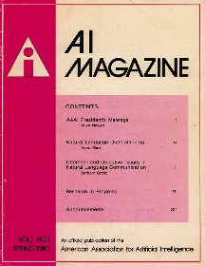
Figure 1: The First AI Magazine Cover.
(This is an example of the required figure caption style.
The illustration uses the required Figure stylesheet)
You must leave a minimum of one carriage return between a figure or table and its surrounding text.
Drawings
We suggest you use computer-drawing software (such as Adobe Illustrator or, (if unavoidable), the drawing tools in Microsoft Word) to create your illustrations. Do not use Microsoft Publisher. These illustrations will look best if all line widths are uniform (half- to two-point in size), and you do not create labels over shaded areas. Shading should be 133 lines per inch if possible. Use Times New Roman or Helvetica for all figure call-outs. Do not use hairline width lines — be sure that the stroke width of all lines is at least .5 pt. Zero point lines will print on a laser printer, but will completely disappear on the high-resolution devices used by our printers.
Photographs and Images
Photographs and other images should be in grayscale (color photographs will not reproduce well; for example, red tones will reproduce as black, yellow may turn to white, and so forth) and set to a minimum of 300 dpi. Do not prescreen images.
Algorithms and Listings
Algorithms are a special kind of figures. Like all illustrations, they should appear floated to the top (preferably) or bottom of the page. However, their caption should appear in the header, left-justified and enclosed between horizontal lines, as shown in Algorithm 1. The algorithm body should be terminated with another horizontal line. It is up to the authors to decide whether to show line numbers or not, how to format comments, etc. We suggest placing the algorithm inside a text box to ease positioning when using MS Word.
Algorithm 1: Example Algorithm
Input: Your algorithm’s input
Parameter: Optional list of parameters
Output: Your algorithm’s input
1: Let t= 0.
2: while condition do
3: Do some action.
4: if conditional then
5: Perform task A.
6: else
7: Perform task B.
8: end if
9: end while
10: return solution
Listing 1: Example listing quicksort.hs
1 quicksort :: Ord a => [a] -> [a]
2 quicksort [] = []
3 quicksort (p:xs) = (quicksort lesser) ++
[p] ++ (quicksort greater)
4 where
5 lesser = filter (< p) xs
6 greater = filter (>= p) xs

Listings are much like algorithms. They should also appear floated to the top (preferably) or bottom of the page. Font size in Listings must be nine-point Courier New. Listing captions should appear in the header, left-justified and enclosed between horizontal lines as shown in Listing 1. Terminate the body with another horizontal line and avoid any background color. Line numbers, if included, must appear within the text column.
References
Reference citations in the text should appear in author-year format, for example (Smith 1975). References of the same year by the same author(s) should be distinguished by small letters following the year, for example (Smith 1977c) and ordered alphabetically by title. Use a narrative citation form when referring to a paper in a narrative context. For example, say “In his paper, Michael Youngblood (2017) refers to ....” instead of (Youngblood 2017) refers to....”
All entries in the reference list must be cited in the text. In-text citations of four or more authors should be shortened to “first author et al.” For example, the university technical report reference in the sample that follows would be cited as (Vattam et. al. 2013) in the text because it contains four authors.
Generally, references include the name of the author (surname first, followed by initials only for given names) and the date, followed by a period, then the title, presented in mixed case. For multiple authors, separate two names with a comma, and three or more authors with a semicolon. The place of publication (which is required for all book and proceedings publications) is followed by a colon, with the name of the publisher following. For journal articles and serial publications, provide the volume and issue numbers as well as the page numbers. DOIs are strongly for serial publications if they have been assigned. For conference papers, and book chapters, give inclusive page numbers. Provide the DOI if it is available. Do not use shorthand abbreviations (such as AAAI-19) — spell out the full title of the publication.
If you are citing an ephemeral or general page of a website (such as, but not limited to, the landing page of a company or product), please do not include the citation in the reference list. Instead, incorporate the URL into a footnote. All references must contain author, title, and date information.
To meet CrossRef requirements, all cited journal articles within a reference list should include a DOI if one has been assigned.
References should be listed alphabetically (by surname of the primary author or main entry) at the end of the article. Multiple references by the same author(s) should be listed in ascending chronological order with the earliest reference first (for example, Matthews 1979 precedes Matthews 1986). Information for each reference should be in the sequence illustrated by the following examples.
Dissertation or Thesis
(Note: Include department and university):
Clancey, W. J. 1979b. Transfer of Rule-Based Expertise through a Tutorial Dialogue. PhD dissertation, Department of Computer Science, Stanford University, Stanford, CA.
Forthcoming Book
Clancey, W. J. Forthcoming. The Engineering of Qualitative Models. Redwood City, CA: Addison-Wesley Publishing Company.
Preprint Server
Agrawal, A.; Batra, D.; and Parikh, D. 2016. Analyzing the Behavior of Visual Question Answering Models. arXiv preprint. arXiv:1606.07356v2 [cs.CL]. Ithaca, NY: Cornell University Library.
Published Book
Petroski, H. 1985. To Engineer Is Human: The Role of Failure in Successful Design. New York: St. Martin's Press.
Chapter in Published Book
Brown, J. S. 1977. Artificial Intelligence and Learning Strategies. In Learning Strategies, edited by J. O'Neil, 345–78. New York: Academic Press.
Forthcoming Journal Article
O'Connor, J. L. Forthcoming. Artificial Intelligence and Commonsense Reasoning. AI Magazine 44(3).
Published Journal or Magazine Article
Cox, M. T. 2007. Perpetual Self-Aware Cognitive Agents. AI Magazine 28(1): 32–45. doi.org/10.1609/aimag.v28i1.2027.
Paper Presented at Meeting
(Note: Use this format only if no published proceedings appeared):
Schoenfeld, A. H. 1981. Episodes and Executive Decisions in Mathematical Problem Solving. Paper presented at the 1981 AERA Annual Meeting. Boston, MA, September 24–30.
Zhou, S.; Suhr, A.; and Artzi, Y. 2017. Visual Reasoning with Natural Language. Paper presented at the AAAI 2017 Fall Symposium on Natural Communication for Human-Robot Collaboration. Arlington, VA, November 9–11.
Paper Presented at Meeting and Published in Proceedings
Lester, J.; Converse, S.; Kahler, S.; Barlow, T.; Stone, B.; and Bhogal, R. 1997. The Persona Effect: Affective Impact of Animated Pedagogical Agents. In Proceedings of the ACM SIGCHI Conference on Human Factors in Computing Systems.New York: Association for Computing Machinery. doi.org/10.1145/258549. 258797.
Company Technical Report
Carbonell, J. R. 1970. Mixed-Initiative Man-Computer Instructional Dialogues, Technical Report QW-19871. Marina del Rey, CA: USC/Information Sciences Institute.
Scholarly Society Technical Report
Lin, F. 2007. Finitely-Verifiable Classes of Sentences. In Logical Formalizations of Commonsense Reasoning: Papers from the 2007 AAAI Spring Symposium. Technical Report SS-07-05. Palo Alto, CA: AAAI Press.
University Technical Report
Vattam, S.; Klenk, M.; Molineaux, M.; and Aha, D. W. 2013. Breadth of Approaches to Goal Reasoning: A Research Survey. In Goal Reasoning: Papers from the ACS Workshop, edited by D. W. Aha, M. T. Cox, and H. Muñoz-Avila. Technical Report CS-TR-5029. College Park, MD: University of Maryland, Department of Computer Science.
ArXiv Paper
Bouville, M. 2008. Crime and punishment in scientific re-
search. arXiv:0803.4058.
Website or online resource
NASA. 2015. Pluto: The ’Other’ Red Planet. https://www.
nasa.gov/nh/pluto-the-other-red-planet. Accessed: 2018-
12-06.
You are required to use the above AAAI reference format in your paper. If you fail to do so, your paper will be returned to you for reformatting (and a resubmission fee will apply). In addition, you must apply the buildt-in References style (which will automatically format your references in 9 point Time Roman with 10 point line spacing, and 3 additional points of space between each entry.
For the most up to date version and complete version of the AAAI reference style, please consult the AI Magazine Author Guidelines at
aaai.org/ojs/index.php/aimagazine/about/submissions#authorGuidelines.
Proofreading Your PDF
Please check all the pages of your PDF file. Is the page size A4? Are there any type 3, Identity-H, or CID fonts? Are all the fonts embedded? Are there any areas where equations or figures run into the margins? Did you include all your figures? Did you follow the title-case capitalization rules for your title? Did you include a copyright notice? Do any of the pages scroll slowly (because the graphics draw slowly on the page)? Are URLs underlined and in color? You will need to fix these common errors before submitting your file.
Improperly Formatted Files
In the past, AAAI has corrected improperly formatted files submitted by the authors. Unfortunately, this has become an increasingly burdensome expense that we can no longer absorb (we are charged double for papers that require reformatting). Consequently, if your file is improperly formatted, it will probably be returned to you by the outside Production agency. If that happens, you will be required to fix your file and pay a resubmission fee.
Naming Your Electronic File
We require that you name your Word source file with the last name (family name) of the first listed author so that it can easily be differentiated from other submissions. Complete file-naming instructions will be provided to you in the submission instructions.
Submitting Your Electronic Files to AAAI
Submitting your files to AAAI will be provided to you with submission instructions for your conference. Please consult this document for details on how to submit your paper.
Inquiries
If you have any questions about the preparation or submission of your paper as instructed in this document, please contact AAAI Press at the address given below. If you have technical questions about implementation of the aaai style file, please contact an expert at your site. We do not provide technical support for Word or any other software package. To avoid problems, please keep your paper simple, and do not incorporate complicated macros and style files.
AAAI Press
1101 Pennsylvania Ave, NW Suite 300
Washington, DC 20004 USA
Telephone: 1-202-360-4062
E-mail: See the submission instructions
for your particular conference or event.
Acknowledgments
The preparation of the files that implement these instructions was supported by The Live Oak Press, LLC, and AAAI Press.

Thank you for reading these instructions carefully. We look forward to receiving your electronic files!

